5M Communications Plan Overview

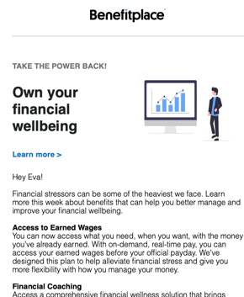
and Template Instructions
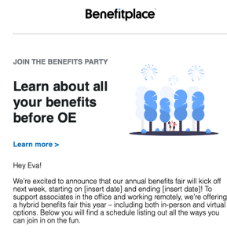
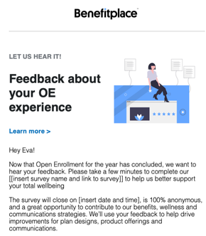

The 5M Framework
Strategic communications simply mean that your messages are thoughtfully planned and well executed. For that reason, we recommend using the 5M framework, including the five basic components of a solid communication strategy.

With this helpful communications framework and corresponding communication templates, you can design a comprehensive open enrollment communications strategy to maximize employee engagement. This means providing the right level of benefits education, at the right time, to help employees make the best benefit enrollment decision. When taking a multi-faceted communications approach to your open enrollment, employees are more engaged and are more likely to actively participate.

How to Use this Document
- Use this sample 5M Communications Plan as a framework to adapt and tailor messages before, during and after open enrollment.
- Click the link in the “Message” column to access the communication templates available as part of the Smart Moments Library. To access these communication templates, you must first be logged into One Place 365 before selecting the link.
- From there, you can view the messaging to use and tailor via your preferred communication methods including, but not limited to, the Smart Moments Console.

Need More Help with Smart Moments?
- Check out this short video on how to set up a message via the Smart Moments Console using the HTML attached to each communication template available via the Smart Moments Library.
- Download the Smart Moments Playbook for additional information about ways you can increase employee engagement with year-round communications.

Message | Market | Media | Moment | Measure
What do you want to communicate? | Who do you want to communicate to? | How will you communicate (document, email, webinar, video) | When will you communicate and who is the owner of the communication? | How will you know if the communication is successful? (Survey)
Save the Date: Open Enrollment Starts [insert date] | All benefits eligible employees | Mailer, Email, Text Message or Push Notification, Flyers | 5 weeks prior to OE, Mailer needs to be mailed 6-7 weeks prior | Direct feedback, Post-OE Survey, Engagement Metrics
Weekly Benefits Spotlight – Benefits that nurture your health and promote wellness | All employees eligible for offerings highlighted | Email, Text Message or Push Notification, Video/Podcast | 4 weeks prior to OE | Direct feedback, Post-OE survey, Video views via YouTube
Weekly Benefits Spotlight – Benefits that help you plan for your future | All employees eligible for offerings highlighted | Email, Text Message or Push Notification, Video/Podcast | 3 weeks prior to OE | Direct feedback, Post-OE survey, Video views via YouTube
Weekly Benefits Spotlight – Benefits that help you protect what matters most | All employees eligible for offerings highlighted | Email, Text Message or Push Notification, Video/Podcast | 2 weeks prior to OE | Direct feedback, Post-OE survey, Video views via YouTube
Weekly Benefits Spotlight – Benefits that can help you stress less financially | All employees eligible for offerings highlighted | Email, Text Message or Push Notification, Video/Podcast | 1.5 weeks prior to OE | Direct feedback, Post-OE survey, Video views via YouTube
Your annual benefit enrollment is one week away | All benefits eligible employees | Email, Text Message or Push Notification | 1 week prior | Direct feedback, Post-OE survey, Video views via YouTube
It’s a Party – Join us for the Benefits Fair this week! | All benefits eligible employees | Hybrid – Virtual webinar with partners and in-person support including SWAG | 1 week prior | Attendance rate, direct feedback, Post-OE survey
For 2 Weeks Only: Open Enrollment for Benefits | All benefits eligible employees | Email, Webinar or Video, Text Message or Push Notification, Mailer | First day of OE (mailer needs to be mailed 1 week prior) | Direct feedback, Post-OE survey
Open Enrollment: 5 Tips on Choosing the Best Insurance | All benefits eligible employees | Email, Text Message or Push Notification | 3 days after OE start | Direct feedback, Post-OE survey, Benefitplace report
Open Enrollment Ends Soon – Here’s Your Checklist | All benefits eligible employees | Email | 6 days prior to OE ending | Direct feedback, Post-OE survey, Benefitplace report
Enroll Now, Before it’s Too Late! | All benefits eligible employees who have not yet enrolled | Email, Text Message or Push Notification | 5 days prior to OE ending | Direct feedback, Post-OE survey, Benefitplace report
Reminder: Open Enrollment Ends Tomorrow | All benefits eligible employees | Email, Text Message or Push Notification | 1 day prior to OE ending | Direct feedback, Post-OE survey, Benefitplace report
Last Chance to Enroll | All benefits eligible employees  All benefits eligible employees who have not yet enrolled | Email – reminder for all  Text Message or Push Notification – not yet enrolled mid-day  Text Message or Push Notification – Not yet enrolled COB | Last day of OE | Direct feedback, Post-OE survey, Benefitplace report
Open Enrollment Experience – Your Feedback Requested | All employees participating in OE | Email, Text Message | 2 business days post OE; multiple reminders to complete before survey close | Survey competition rate and key themes/trends
Benefits that can change with you | All benefits-eligible employee | Email, Text Message or Push Notification | 2 weeks – 1 month post OE | Direct feedback, Benefitplace report

